**REGex Software Services**

**Java Full Stack Development Program**

Registration I'd:  **IIPRSS1404**

Name: **Shanmukh Subhash Kumbhar**

Subject: Assignment 4 - #Command line arguments, Scanner object

Core Java 2021 **Core Java Session 4 Assignments**

**Assignment 1:**

|  |
| --- |
| Accept **student id, name and marks of 6 subjects** using **CommandLine Arguments** and **Scanner**. Calculate **total marks** and **average**.  Print **Student Id, Student Name, Six subject marks, total marks and average**. |
|  |

**Assignment 2:**

**Employee Salary Breakup App**

|  |
| --- |
| Accept **Employ Id, Employ Name, Basic Salary** from end user.  Calculate based on following constraints  **HRA is 2% of Basic**  **PF is 3% of Basic**  **TA is 1% of Basic**  **ESI is 2.5% of Basic**  **Gross Pay is Sum of Basic, HRA, PF, ESI and TA**  **Net Pay is Gross Pay minus PF.**  Print  Employ id, employ name, Basic Sal, hra, pf, ta, esi, Gross Pay, Net Pay as following |

**Input:**

Enter Employ Id : 10101

Enter Employ Name : Jones

Basic Salary : 10000

**Output:**

Salary Break Up Application

===================================================

Employ Id : 10101

Employ Name : Jones

Basic Salary : 10000

HRA : 200

PF : 300

TA : 100

ESI : 250

Gross Pay : 10850

Net Pay : 10550

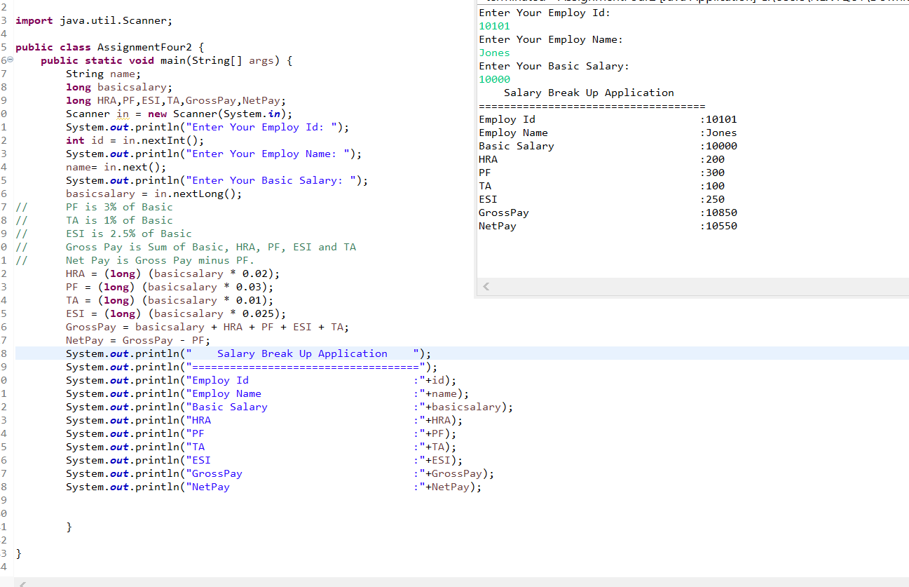

**Page 1**

Core Java 2021 **Practice Statement: Retail Price of a Product**

**A gift store wishes to increase the selling price of its items by 5% due to a hike in the price of raw materials. Write a program that takes the item name and its price as input and displays the revised selling price of the item.**

**Sample Input:**

Enter Item name : Rounded Kaisa Bowl

Enter Selling Price : 10.99

**Sample Output:**

Revised Selling Price for Rounded Kaisa Bowl is $11.539

**Page 2**

Core Java 2021 **Practice Statement: Weighted Average Score**

**Performance of students of an engineering college is evaluated based on marks obtained by them in assessments that are carried out throughout the year. The percentage value assigned for each of the different types of assessments conducted is listed below.**

**Sl No Assesment Type Percentage**

1 Assignments 10%

2 Projects 35%

3 Quiz 10%

4 Mid Term 15%

5 Final Exam 30%

**Students need to calculate their weighted average score based on the percentage value of each type of assessment. Write a program that accepts the scores obtained by a student for each of the five different types of assessments and displays the weighted average score of the student.**

**Sample Input:**

Assignments 97

Projects 82

Quiz 60

Mid term 75

Final exam 80

**Sample Output**

Weights % Value of score

Assignments 9.7

Projects 28.699999

Quiz 6.0

Mid term 11.25

Final Exam 24.0

Overall Percentage : 79.649994%

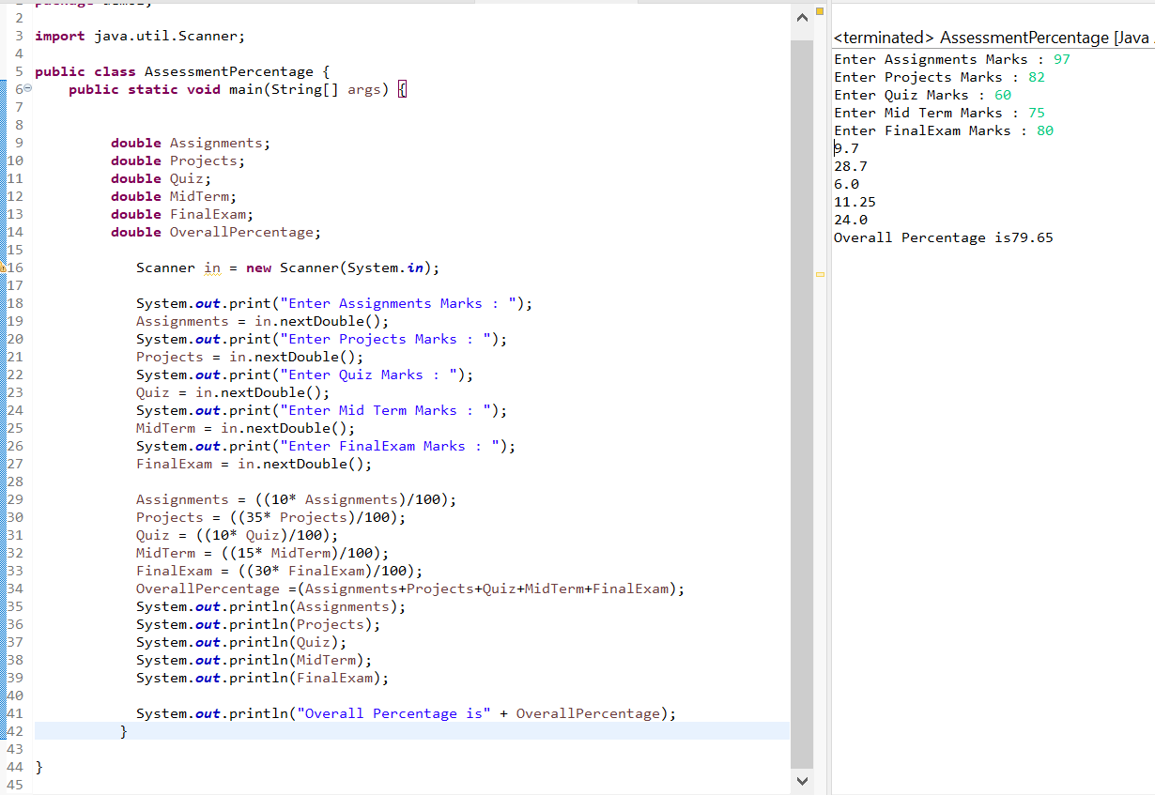

**Page 3**

Core Java 2021 **Practice Statement: Calorie Tracker**

**Anne is using a calorie tracker app that helps her keep a record of all her physical activities and her daily intake of calories The calories burned by her doing some of the common physical activities are:**

1. 30 minutes of cycling burns around 300 calories

2. 30 minutes of swimming burns around 200 calories

3. 30 minutes of running burns around 500 calories

**Anne can lose one pound of weight for each 1000 calories burned. Her daily extra calorie intake tracked by the app is 100 Write a java program to calculate the number of pounds Anne can lose in a month if she does each of the above-mentioned activities once a week for 1 hour and chooses to do one activity per day.**

**Sample Input:**

Calorie burnt by cycling : 200

Calorie burnt by running : 200

Calorie burnt by swimming: 200

Calorie intake in a day : 100

**Sample Output:**

Weight lost by Anne in a month is : 5.0 pounds

**Page 4**